Adverbials in Verb Phrases

- Adverb as an Adverbial in a Verb Phrase
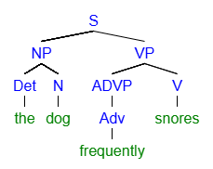

- Prepositional Phrase as an Adverbial in a Verb Phrase

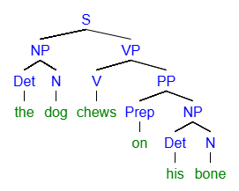

Sentence Adverbials

- Adverb as a Sentence Adverbial

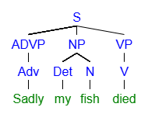
- Prepositional Phrase as a Sentence Adverbial
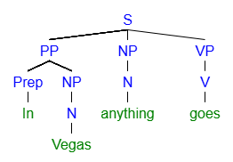

Adverbials in Adjective Phrases
- Adverb as Adverbial in an Adjective Phrase
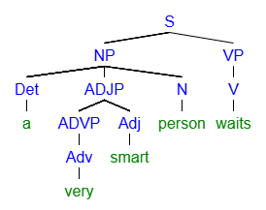
Adverbials in Adverb Phrases
- Adverb as an Adverbial in an Adverb Phrase
